**SCHOOL OF ENGINEERING AND TECHNOLOGY**

**ASSIGNMENT COVER SHEET**

**COURSE:** NET1014 – Networking Principles

**LEVEL:** BCNS, BIT, BCS, BSE, BDS - Year 1

**ACADEMIC SESSION:** February 2025 Semester

**DEADLINE:** 28th Mar 2025 – 11:59PM

|  |  |  |  |
| --- | --- | --- | --- |
| **#** | **Name** | **Student ID** | **Percentage of contribution** |
| **1** | **Ng Chin Yang** | **23086077** | **30%** |
| **2** | **Hoo Kang Wei** | **23056807** | **20%** |
| **3** | **Clement Chong Hoy Mun** | **23068414** | **30%** |
| **4** | **Choo Yi Herng** | **23070139** | **10%** |
| **5** | **Ken Tan Khai Wen** | **23068695** | **10%** |

**Introduction**

The Open Systems Interconnection (OSI) model is a conceptual framework that standardizes the functions of a communication system into seven distinct layers. Each layer serves a specific role, ensuring seamless interaction between devices and networks. This document provides an in-depth analysis of the OSI mode which includes its layers, functions, tasks, associated protocols, advantages, challenges, and a critical evaluation.

**The Seven Layers of the OSI Model**

**1. Physical Layer (Layer 1)**

**Function:**

* Responsible for the physical connection between devices.
* Transmits raw bitstreams over a physical medium.
* Defines hardware elements such as cables, switches, and network adapters.

**Tasks:**

* Data encoding and signaling.
* Bit rate control.
* Transmission mode (simplex, half-duplex, full-duplex).
* Media type (wired or wireless) and connector specifications.

**Common Protocols and Real-World Examples:**

* **Ethernet (IEEE 802.3):** Used in wired LAN connections in homes and offices.
* **Wi-Fi (IEEE 802.11):** Commonly used in wireless networking for internet access.
* **Bluetooth:** Enables wireless communication between devices like headphones and smartphones.
* **USB:** Used for direct wired communication between devices.

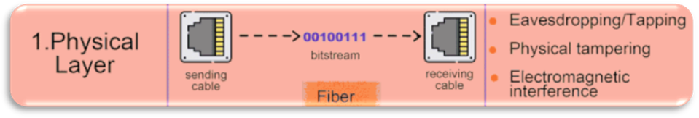

**2. Data Link Layer (Layer 2)**

**Function:**

* Handles error detection and correction.
* Establishes reliable point-to-point connections between nodes.
* Manages Media Access Control (MAC) addressing.

**Tasks:**

* Framing data packets.
* Addressing using MAC addresses.
* Flow control and error handling.
* Collision detection and avoidance (e.g., CSMA/CD in Ethernet).

**Common Protocols and Real-World Examples:**

* **Ethernet (IEEE 802.3):** Used in wired network connections for data transmission.
* **PPP (Point-to-Point Protocol):** Used in direct connections, such as DSL and VPNs.
* **MAC (Media Access Control):** Used for unique addressing in local area networks.
* **ARP (Address Resolution Protocol):** Resolves IP addresses to MAC addresses for network communication.

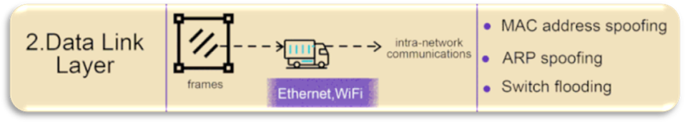

**3. Network Layer (Layer 3)**

**Function:**

* Responsible for routing and addressing packets across networks.
* Uses logical addressing (IP addresses).
* Facilitates inter-networking between different network architectures.

**Tasks:**

* Logical addressing (IPv4, IPv6).
* Path determination and packet forwarding.
* Routing protocols to determine best paths.

**Common Protocols and Real-World Examples:**

* **IP (Internet Protocol, IPv4, IPv6):** The backbone of internet communication.
* **ICMP (Internet Control Message Protocol):** Used for error reporting (e.g., ping command).
* **OSPF (Open Shortest Path First):** A routing protocol used in large networks.
* **RIP (Routing Information Protocol):** Used for small-scale network routing.

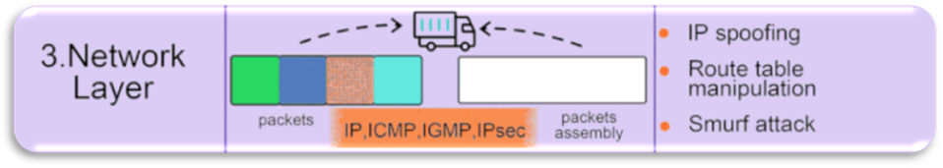

**4. Transport Layer (Layer 4)**

**Function:**

* Ensures reliable or best-effort data transfer.
* Provides end-to-end communication between devices.
* Manages segmentation, flow control, and error correction.

**Tasks:**

* Establishing and terminating connections (TCP three-way handshake).
* Flow control using windowing mechanisms.
* Error detection and correction.
* Data segmentation and reassembly.

**Common Protocols and Real-World Examples:**

* **TCP (Transmission Control Protocol):** Used for reliable communication in applications like web browsing and emails.
* **UDP (User Datagram Protocol):** Used for real-time applications like video streaming and online gaming.
* **SCTP (Stream Control Transmission Protocol):** Used in signaling applications like VoIP.

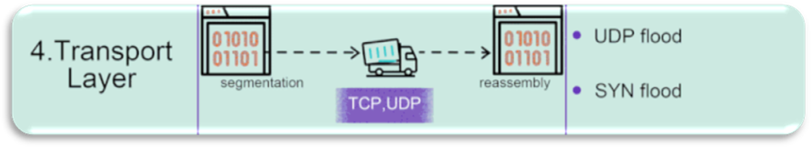

**5. Session Layer (Layer 5)**

**Function:**

* Manages and controls communication sessions between applications.
* Establishes, maintains, and terminates sessions.
* Handles authentication and authorization.

**Tasks:**

* Synchronization of data exchange.
* Checkpointing and recovery of sessions.
* Managing session states.

**Common Protocols and Real-World Examples:**

* **NetBIOS (Network Basic Input/Output System):** Used in older Windows networking.
* **RPC (Remote Procedure Call):** Used in distributed computing applications.
* **PPTP (Point-to-Point Tunneling Protocol):** Used in VPN connections.

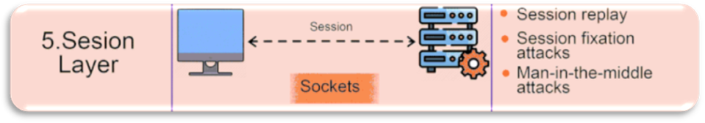

**6. Presentation Layer (Layer 6)**

**Function:**

* Converts data into a format that can be understood by the application layer.
* Handles encryption, compression, and translation of data formats.

**Tasks:**

* Data encryption and decryption (e.g., SSL/TLS).
* Data compression and encoding.
* Character encoding (ASCII, Unicode).

**Common Protocols and Real-World Examples:**

* **SSL/TLS (Secure Sockets Layer / Transport Layer Security):** Used in securing web communications (HTTPS websites).
* **JPEG, GIF, PNG (Image formats):** Used for digital media representation.
* **MPEG, MP3 (Multimedia formats):** Used for media streaming and audio files.

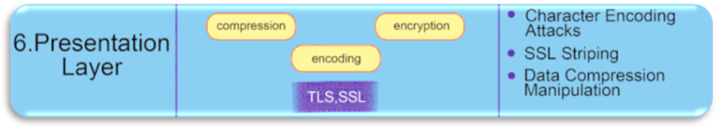

**7. Application Layer (Layer 7)**

**Function:**

* Provides network services to end-user applications.
* Facilitates communication between software applications and network services.

**Tasks:**

* Data formatting and interpretation.
* Network request-response handling.
* User authentication and authorization.

**Common Protocols and Real-World Examples:**

* **HTTP/HTTPS (Hypertext Transfer Protocol):** Used for web browsing.
* **FTP (File Transfer Protocol):** Used for file sharing and transfer.
* **SMTP (Simple Mail Transfer Protocol):** Used for sending emails.
* **DNS (Domain Name System):** Resolves domain names to IP addresses.

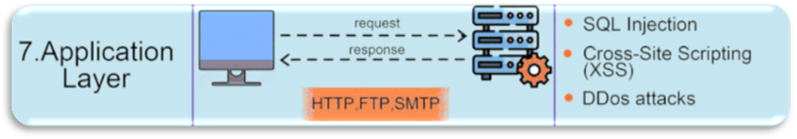

**Full Visualization**

**Critical Evaluation of the OSI Model**

**Advantages**

1. **Modular Approach:** The OSI model provides a clear separation of concerns, making network design and troubleshooting easier.
2. **Interoperability:** Encourages standardization, allowing devices and systems from different vendors to communicate effectively.
3. **Scalability:** The layered structure allows new technologies to be integrated without disrupting existing systems.
4. **Security:** Different layers can implement security features such as encryption and authentication independently.
5. **Structured Learning:** Provides a systematic framework for networking professionals to understand complex network interactions.

**Challenges**

1. **Theoretical Nature:** The OSI model is more of a reference framework than a practical implementation. Many modern networks use the TCP/IP model, which is simpler and more widely adopted.
2. **Complexity:** The seven-layer structure can be overly detailed for some applications, leading to inefficiencies in real-world implementations.
3. **Redundancy Between Layers:** Some tasks, such as error handling and flow control, are performed at multiple layers, which can lead to inefficiencies.
4. **Slower Adoption:** While it provides a structured approach, industry adoption of the OSI model has been slow compared to the more streamlined TCP/IP model.
5. **Limited Direct Implementation:** Real-world networking protocols (like TCP/IP) do not strictly adhere to the OSI layers, making the model less applicable in practice.

**1. List of Required Equipment & Justification**

Below is a breakdown of the networking equipment used in the network design and its justification:

|  |  |  |
| --- | --- | --- |
| **Equipment** | **Quantity** | **Justification** |
| **Routers (Cisco ISR4331)** | 2 | Used for inter-network communication, connecting different network segments, and routing data between subnetworks. |
| **Switches (Cisco 2960-24TT)** | 3 | Provides network connectivity within each subnet, allowing multiple devices to communicate efficiently. |
| **Access Points** | 3 | Enables wireless connectivity for laptops, tablets, and smartphones within different network segments. |
| **Servers** | 3 | Hosts essential network services such as file sharing, applications, and possibly DHCP/DNS. |
| **PCs (Workstations & IoT Devices)** | 13+ | Represents end-user devices used for daily operations and connectivity testing. |
| **Laptops** | 6+ | Provides wireless connectivity for mobility users. |
| **Printers** | 2 | Enables network-wide printing services for various departments. |
| **Cabling (Ethernet & Fiber Optic)** | Various | Connects wired devices to switches and routers for stable communication. |
| **IP Addressing & Subnetting** | N/A | Logical segmentation of the network to optimize performance and security. |

**2. Estimated Cost of Equipment**

Below is a rough estimation of the cost of networking equipment, based on average Cisco prices:

|  |  |  |  |  |
| --- | --- | --- | --- | --- |
| **Equipment** | **Quantity** | **Estimated Unit Cost (USD)** | **Total Cost (USD)** | **Total Cost (MYR)** |
| **Cisco ISR4331 Router** | 2 | $2,500 | $5,000 | **23,750 MYR** |
| **Cisco 2960-24TT Switch** | 3 | $1,200 | $3,600 | **17,100 MYR** |
| **Wireless Access Points** | 3 | $300 | $900 | **4,275 MYR** |
| **Servers** | 3 | $3,000 | $9,000 | **42,750 MYR** |
| **PCs (Desktops/Workstations)** | 13 | $800 | $10,400 | **49,400 MYR** |
| **Laptops** | 6 | $1,000 | $6,000 | **28,500 MYR** |
| **Printers** | 2 | $500 | $1,000 | **4,750 MYR** |
| **Cabling & Accessories** | Various | $500 | $500 | **2,375 MYR** |

**Total Estimated Cost in MYR: ≈ 173,900 MYR**

**3. Physical Topology**

Since the topology requirements are Sunway University 3rd Floor Building and SET Building. We chose our physical topology at Subang Jaya.

There are two physical topologies stating HUMAC and SET Building.

This is an example floor plan for the new SET Building.

This is generic container inside the new SET Building.

These are the closet for 3 of the physical topology in SET Building.

This is the generic container for HUMAC Sunway University 3rd floor Building physical topology.

This is the closet for HUMAC Building.

**4. Logical Topology**

IoT Lab Logical Topology

HUMAC Lab Logical Topology

Communications Lab (CL) Logical Topology

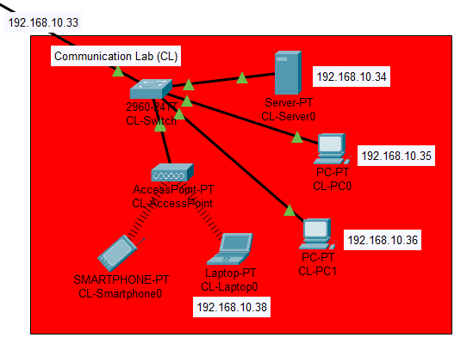

Advanced Wireless Lab (AWL) Logical Topology

HUMAC Router

SET Building Router

Router is connected through fiber cable.

4 Switches each for one lab

IP Address and Subnet Masks are as below:

|  |  |  |  |  |  |  |  |  |
| --- | --- | --- | --- | --- | --- | --- | --- | --- |
| **192.168.10.0/24** | | | | | | | |  |
| **LAN** | **REQUIREMENT** | **SUBNET MASK** | **USABLE HOST** | **NETWORK ADDRESS** | **FIRST USABLE IP ADDRESS** | **LAST USABLE IP ADDRESS** | **BROADCAST ADDRESS** | **Default Gateway** |
| **HUMAC** | 12 | 255.255.255.224 | 30 | 192.168.10.0 | 192.168.10.1 | 192.168.10.30 | 192.168.10.31 | 192.168.10.1 |
| **Communications Labs** | 5 | 255.255.255.240 | 14 | 192.168.10.32 | 192.168.10.33 | 192.168.10.46 | 192.168.10.47 | 192.168.10.33 |
| **Advanced Wireless Lab** | 7 | 255.255.255.240 | 14 | 192.168.10.48 | 192.168.10.49 | 192.168.10.62 | 192.168.10.63 | 192.168.10.49 |
| **IoT Lab** | 10 | 255.255.255.240 | 14 | 192.168.10.64 | 192.168.10.65 | 192.168.10.78 | 192.168.10.79 | 192.168.10.65 |
| **WAN** | 2 | 255.255.255.252 | 2 | 192.168.10.80 | 192.168.10.81 SET | 192.168.10.82 HUMAC | 192.168.10.83 |  |

**Part C: Lessons Learned**

**Teamwork Experience:**

We had coordinated our task roulette wheel to ensure fairness. Communicated through WhatsApp and offline meetings in campus. Dr Maisarah Mansor was very kind to answer our questions and help us throughout our Project.

**Technical Challenges:**

Router configuration has been a problem where we couldn’t send a packet to another host due to less exercise on this matter. Moreover, there are no examples for us students to refer to. It makes this Project harder than we expected. The due date issue for this project requires more time since there is Logical and Physical topology.

**Issue Resolution:**

We have gone through a lot of research online and seek Dr Maisarah’s help, and we are able to overcome challenges.

**Overall Experience:**

This project gave us inspiration and knowledge of how the Internet works. We can configure and build our own network from routers, switches and hosts. It is for students to get involved in hands-on learning.